 | SCHOOL OF COMPUTING  FACULTY OF ENGINEERING  UNIVERSITI TEKNOLOGI MALAYSIA

PSM 1 (SECJ 3032)
PROJECT PROPOSAL FORM

Session/Semester: 20222023/2

Instruction: Please complete and submit this form to the departmental PSM committee. The proposal must be reviewed by the supervisor before submission.

SECTION A: STUDENT INFORMATION

Name | Iman Aidi Elham bin Hairul Nizam
Year/Course | 3 SECJ
IC. No. | 000122-10-0043 | Matric No. | A20EC5006
Email | imanaidielham@graduate.utm.my | Mobile No. | 011-54225852

Proposal No. | 1 | (Please follow your preference. Proposal No. 1 – the highest priority, followed by Proposal No. 2 Each student may propose a maximum of 2 topics).

SECTION B: PROJECT DETAILS
Supervisor Name: | Associate Prof. Ts. Dr. Mohd Shahizan bin Othman
Project Title: | Preserving Cultural Heritage Sites through Random Forest & XGBoost Algorithm for Microclimate Monitoring & Prediction

Problem Background and Proposed Solution:

The preservation of cultural heritage sites is a significant challenge that requires constant attention and care. Unfortunately, due to the lack of proper maintenance, many heritage sites suffer from gradual deterioration. The traditional methods of maintenance often used in the past were reactive, meaning that significant damage had already occurred before any action was taken. This reactive approach has resulted in many heritage sites being lost forever.

To address this problem, proactive measures are needed to detect potential issues and suggest preventive maintenance actions to preserve the site's aesthetics and cultural values. In this research proposal, we aim to preserve heritage architecture in Johor Bahru, Malaysia, by leveraging machine learning-based microclimate monitoring.

The proposed solution involves collecting microclimate data from the Malaysian Meteorological Department and analyzing it using appropriate machine learning algorithms, such as Random Forest and XGBoost, for microclimate monitoring and prediction. By comparing the performance of these two algorithms, this research aims to identify the most suitable method for predicting potential issues and suggesting preventive maintenance actions. Other than that, a user-friendly dashboard will be designed at the end stage of this research which will display real-time microclimate data based on the model's output. The developed model and dashboard will be evaluated and tested to ensure effectiveness in assisting local authorities with heritage site preservation.

This approach has the potential to be adapted and applied to other heritage sites in Malaysia and beyond. By contributing to the broader goal of safeguarding cultural heritage sites for future generations, this research will help to ensure that these important sites are preserved and appreciated for years to come.

System Architecture:

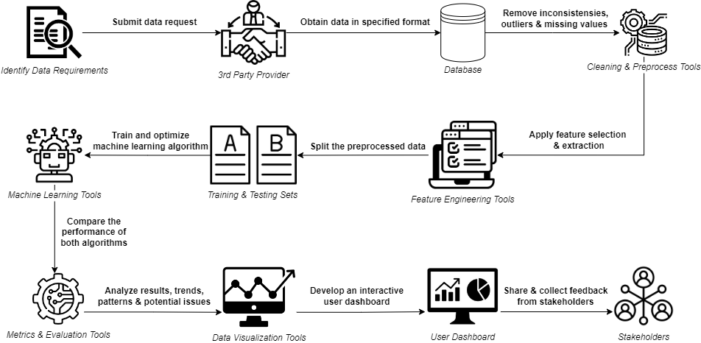
Figure 1 : System Architecture

- Data Collection
- Obtain microclimate data (temperature, humidity, wind speed) from the Malaysian Meteorological Department (MET Malaysia) for a designated heritage site in Johor Bahru.

- Data Preprocessing
- Clean and preprocess the raw microclimate data, handling missing values and outliers.
- Perform feature engineering to create relevant features for capturing temporal dependencies and relationships between variables.

- Machine Learning Model Development
- Split the preprocessed data into training and testing sets.
- Train and optimize the Random Forest and Extreme Grading Boosting (XGBoost) algorithms on the training data.
- Compare the performance of the two algorithms using appropriate evaluation metrics (e.g., mean absolute error, mean squared error, etc.).

- Preventive Maintenance Strategy
- Analyze the results and insights from the trained machine learning models.
- Identify trends, patterns, and potential issues that may impact the heritage site.

- Dashboard Development
- Design and develop a user-friendly dashboard that displays real-time microclimate data.
- Integrate the trained machine learning models into the dashboard to provide recommendations for maintenance actions.
- Provide visualization tools to help users understand trends and patterns in microclimate data.

- Evaluation and Testing
- Test the effectiveness of the developed machine learning models and dashboard in assisting local authorities with planning preventive maintenance actions.
- Assess the performance and usability of the dashboard.
- Gather feedback from users and stakeholders to refine the system and make improvements as needed.
Objectives:

- To investigate and identify the most suitable machine learning algorithms for analyzing microclimate data, with the aim of recognizing patterns, trends, and potential issues related to the heritage site's preservation.
- To design a preventive maintenance strategy based on the insights gained from the microclimate data analysis, which suggests appropriate maintenance actions to preserve the site's aesthetics and cultural values.
- To create a user-friendly dashboard that displays real-time microclimate data and provides recommendations for maintenance actions to assist local authorities with heritage site preservation.

Scopes:

The scope of this research project covers several aspects related to the preservation of heritage architecture in Johor Bahru, Malaysia, using machine learning-based microclimate monitoring. The primary focus is on the development of a dashboard to collect, display, and analyze microclimate parameters for assisting the local authority in planning preventive maintenance actions. The specific areas included in the scope of this research are:
- The research involves obtaining microclimate data from the Malaysian Meteorological Department (MET Malaysia) for a designated heritage site in Johor Bahru. This data includes parameters such as temperature, humidity and wind speed.
- The study will explore various machine learning algorithms, such as Random Forest and XGBoost, to analyze the collected data, identify trends and patterns, and predict potential issues that may impact the heritage site. The performance of these algorithms will be compared to determine the most suitable method for microclimate monitoring and prediction.
- The project includes designing and developing a user-friendly dashboard that displays real-time microclimate data and suggests appropriate maintenance actions for the heritage site.
- The research will involve testing the effectiveness of the developed algorithm and dashboard in assisting local authorities with planning more effective maintenance plans for the heritage site.

Project Requirements:
Software | : Alteryx, MongoDB
Hardware | : A computer with at least 10 GB of free disk space, 8GB of RAM & 2.4 GHz processor.
Technology/Technique/ Method/Algorithm | : Random Forest, Extreme Grading Boosting (XGBoost)
Network Elements | : Data access, internet connectivity.
Security Elements | : Data privacy, compliance with data protection regulations, ethical considerations, secure coding practices.
Project Type:
[ ] System Development

[ / ] Research

Project Area:
Area | : Machine Learning

SECTION C: STUDENT ACKNOWLEDGEMENT
I confirm that this project is:
[ ] My own idea
[ / ] Proposed by the supervisor: Associate Prof. Ts. Dr. Mohd Shahizan bin Othman.

Date: 5 April 2023 |  | Student Signature: ……………………………...

SECTION D: SUPERVISOR ACKNOWLEDGEMENT

I ………………………………………………………………………………… confirm that I have reviewed this student’s project proposal and therefore agree for the proposal to be submitted for evaluation.
Date | : ………………………… | Signature  Official Stamp | : …………………

SECTION E: EVALUATION PANEL APPROVAL

Outcome:
[ ] Full Approval
[ ] Conditional Approval (Minor)
[ ] Conditional Approval (Major)
[ ] Fail

Notes (Please state reasons for conditional or failed approval)
……………………………………………………………………………………………
……………………………………………………………………………………………
Evaluation Panel:

1. …………………………………………..
2. …………………………………………..
Date: ……………………… |  | Signature: …..……………………………  Name: …..……………………………….

SECTION F: FOR FACULTY COMMITTEE ONLY

Date Received: ……………………………….

Signature : ………………………………. (Official Stamp)

